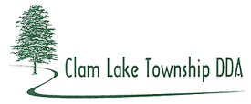
2013 ANNUAL SYNOPSIS

Sewer – The focus of the DDA was to get sewer for the DDA District. The Township negotiated a Sewer Agreement for the DDA District with the City of Cadillac, but the Agreement was not executed.

