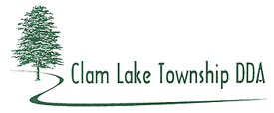
2014 ANNUAL SYNOPSIS

Sewer - Discussions ceased on obtaining sanitary sewer from the City of Cadillac due to the TeriDee Lawsuit. The TeriDee lawsuit started with the property owner seeking annexation from Clam Lake Township for development purposes to obtain public sewer and water. Clam Lake Township entered into a PA 425 with adjacent Haring Charter Township as Haring could provide utilities to the TeriDee property.

