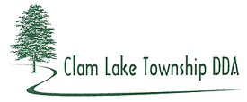
2015 Synopsis

The DDA worked with Mansfield Land Use Consultants on a Strategic Plan.

The US 131 BR Sidewalk was constructed on a cost share with the Township.

The TeriDee Lawsuit continues. The Township and the DDA discussed a possible Joint Sewer Authority with Clam Lake, Cherry Grove and Selma Townships.

