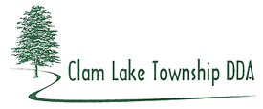
2017 Synopsis

The DDA worked with MSU’s Engineering Department on a “Safe Routes 2 School” grant program and allocated $2,000 for the out-of-pocket fees for MSU. This is a $200,000 grant program to make school more walkable/bikeable with sidewalks and paths.

The DDA approved $5,000 for a “Welcome to the Cadillac Area” design by DK Design Group for US 131 Exit 177.

The DDA had the concrete on the light pole islands cleaned and sealed with a cost of $6,100.

The Supreme Court ruled in favor of Haring and Clam Lake Township’s PA 425 agreement. The City of Cadillac sued and the lawsuit continues.

Clam Lake Township hired Planning Consultants Beckett & Raeder for a Master Plan and Zoning Ordinance. The DDA participated in the discussions. The DDA requested that a DDA Member be appointed to the Planning Commission.

