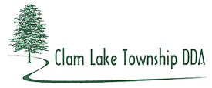
2018 Synopsis

The DDA funded 25% ($5,000) of a M-115 & M-55 Corridor Redevelopment Plan Study, which included the DDA District. Networks Northwest performed the study and Alliance for Economic Success was a partner.

The “Safe Routes 2 School” Grant Program Action Plan was completed by MSU. The Cadillac School District is having a Safe Routes study done for three of their schools in the City of Cadillac. The DDA is hoping to partner with the City for one grant application for the four schools as recommended by the Michigan Fitness Council.

The TeriDee lawsuit continues.

Clam Lake Township Planning Commission and Board adopted a Master Plan and Future Land Use Map. The Planning Commission worked on the Zoning Ordinance update which includes the DDA Distict Overlay. A DDA Member was appointed to the Planning Commission.

